

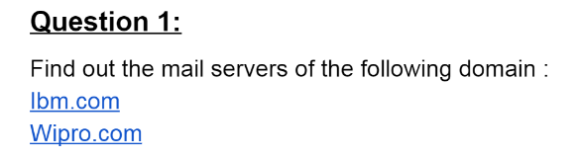

**ANSWER: -**

**Mail Server of ibm.com**

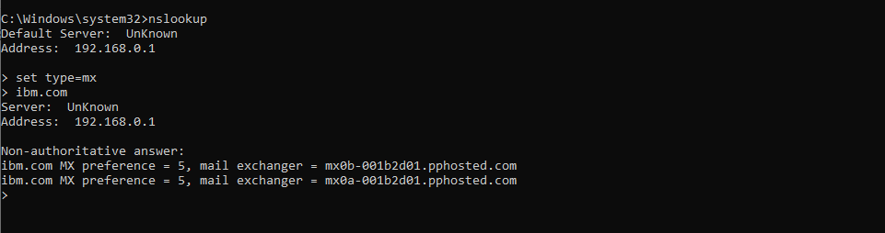

**Mail Server of Wipro.com**

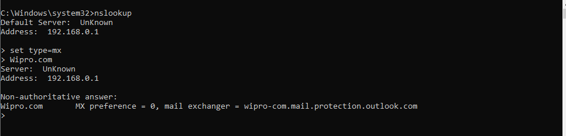

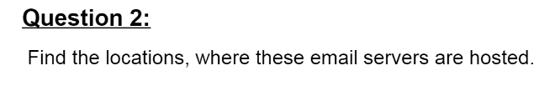

**1)(a) ibm email server mx0a-001b2d01.pphosted.com**

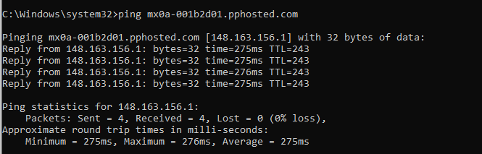

**LOCATION OF IBM (mx0a-001b2d01.pphosted.com) MAIL SERVER**

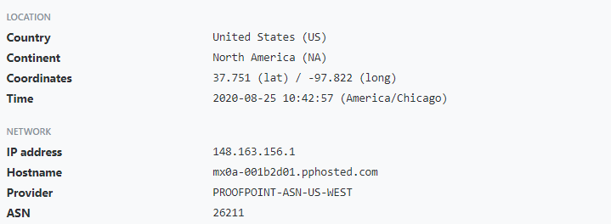

**1)(b) ibm email server mx0b-001b2d01.pphosted.com**

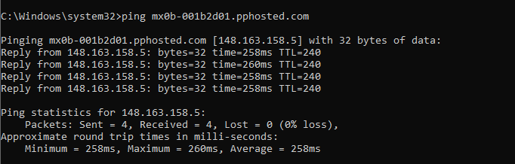

**LOCATION OF IBM (mx0b-001b2d01.pphosted.com) MAIL SERVER**

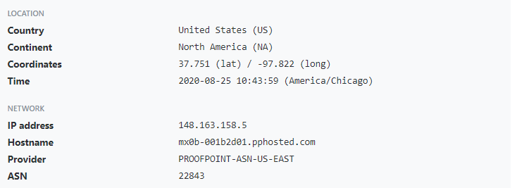

**2) Wipro Email Server wipro-com.mail.protection.outlook.com**



**LOCATION OF WIPRO MAIL SERVER**



 